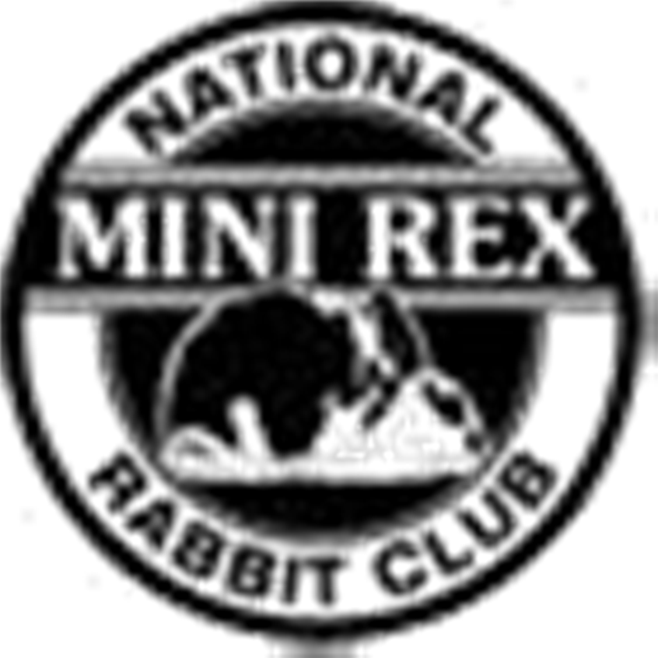

NMRRC Partnership Form
This form must be completed and forwarded to the Secretary of the NMRRC along with a one-time $10 fee for members who reside at different addresses but want to form a partnership. The rules for a partnership state that all animals shown must be housed in one location. Each partner must sign this form confirming all animals are housed in one location.

Please Print Names:
Signatures confirming all animals are housed in one location.

Partner 1 _ Partner 2 _ Partner 3 _ Partner 4 _
Partner 5 _

EXACT names as they will appear on entry forms:

Please print clearly ______

Address where rabbits are housed__________________________________________________

It is the responsibility of the partners to ensure their entries are entered correctly by show secretaries. Please confirm your partnership is correct on your confirmation sheets and show reports. The NMRRC will enter points exactly as submitted by show secretaries.

Return to (with payment if applicable) to: Bridget Forman
8562 290th Street
Boyd, WI 54726

